Travel mart guide

Finance Team

July 2014 For Internal Distribution Only
Contents
Introduction 2
How to log in 3
How to change your password 4
Search a crewmember 5
Crewmember Information 6

Introduction

Last updated: July, 2014
Created by: Chiara van der Kwast
Travel Mart is a web based system created and managed by the Shipboard HR Strategy and Services of Royal Caribbean Cruises Ltd. This tool was designed to provide the users with crewmember travel arrangements. This specific section displays general travel arrangements that the Finance Team might need to refer back to when researching reimbursement approvals.

Note: Reserved arrangements that have not yet been booked will not appear in Travel Mart.

For support or issues with the system, contact SHRSS_Support@rccl.com

How to Log In

Step 1: Go to Https://www.rclcrew.com
Step 2: Enter your Username and Password in the appropriate fields.
Step 3: Click on Log In
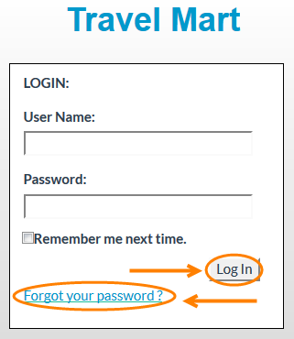
Note: If you are logging in for the first time, enter the username and password provided. Once you have logged in you will be prompted to change your password.
Forgot your password? Click on Forgot your password.
Step 4: Enter your Username and you will receive and email with your password.
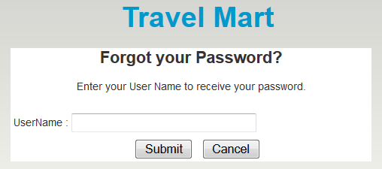

How to change your password

Step 1: At the top right corner of the screen, click on Change Password.
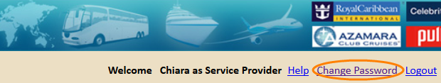
Step 2: In the field Password, enter your current password.
Step 3: In the field New password, enter the new password.
Step 4: Confirm your new password and click on Save.
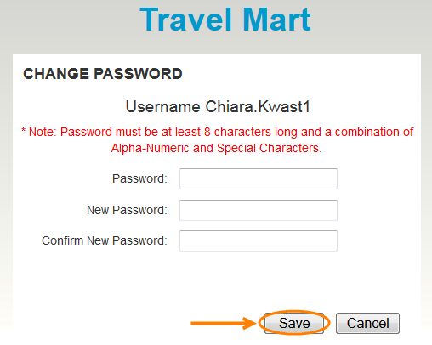

Note: Passwords are case sensitive and must be at least 8 characters long and a combination of Alpha-Numeric and Special Characters.

Search a crewmember
Step 1: Filter crewmember by entering one of the following; Employee ID, Last Name, First Name, and/or Record Locator. You can also filter by ship. Enter Code and/or name of ship.
Step 2: Click on Search.
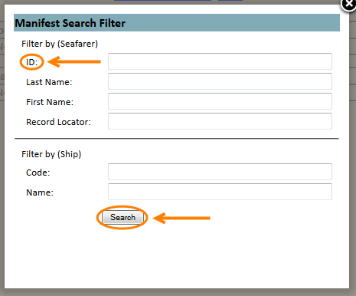
Note: Filtering by Employee ID would be the easiest way to find the correct data seeing as names can have similarities.

Crewmember Information

Once you have found the correct data you can start reviewing the information visible to you.
On the first page you will be able to view future travel arrangements of the crewmember.
- Scroll back and forth to view all the information provided to you. The information that will be displayed is as follows; E1 Travel number, E1 ID, Name, On/Off Date, Crew Status, Reason Code, Port, Brand, Rank, Air Status, Vehicle Status, Hotel Status, Record Locator, Origin-Destination, Meet & Greet, Service Provider, Hotel vender, and Remarks.

Air, Vehicle, and Hotel status refers to if this service has been scheduled for this specific crew member.
This sign indicates that this service has not been scheduled for this specific crewmember.
This sign indicates that this service has been scheduled for this specific crewmember.
- Select View All on the top left of the page to view past travel arrangements. The travel history will be shown in alphabetical order by ship not by date.
- Click on crewmember name. You will be redirected to a page with more detailed information about the crewmember and travel arrangements.
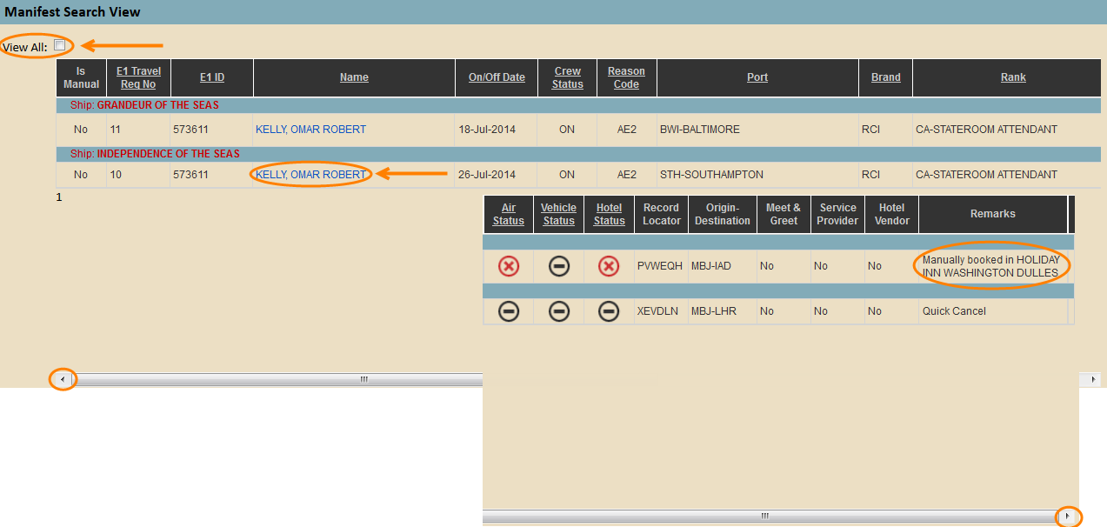
Note: Remarks displayed on the right side of the column are automatically plugged in when changes are made.

In box 1 you will be able to view: E1 ID, Name, Nationality, Gender, Brand, Ship, Rank, Reason Code, Status, Signing ON Date, Signing OFF Date, and Origin/destination.
In box 2 you will be able to posts a remark. See the following steps for further detail.
All other information is as follows: Air Travel, Vehicle, and Port information.
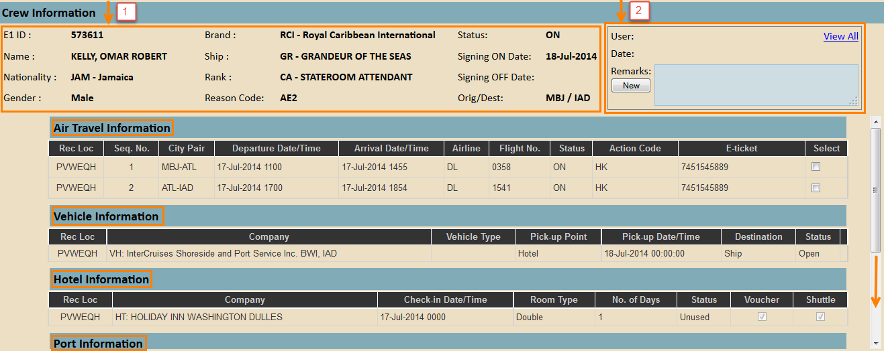

- Post a remark regarding a travel related situation by clicking on New in the comment box on the top right.
- Enter in comment and click on Save or Cancel.
- Click on View All if you wish to view previous remarks made by Crew Assist and/or the Finance Team.
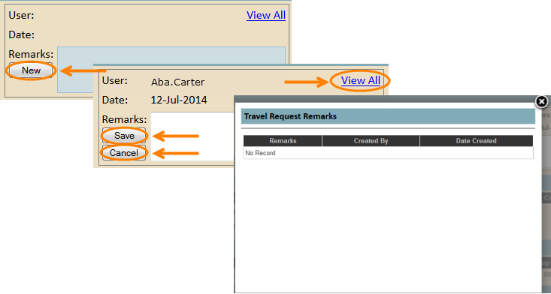
Note: Viewing previous remarks will give the Finance Team visibility on any communication that has taken place between crewmember and crew assist. This will create a better understand of for example, when the crewmember is eligible for reimbursement. It is possible for the Finance Team to post a remark but it is not a necessity. Complaints and decisions made based on financial records are examples of what the Finance Team would be able to fill in a remark about.
- If a meal voucher or Shuttle transportation has been scheduled for the crewmember the box below the word will be checked off.

